

Final Report – Group 75:

PDT Website

By Fraser Yuill, Jamie Kearney, Liam Duff, Sean Mullen, Jake Johnston and Marcin Kazmierkiewicz

**Executive Summary**

This project involves us creating a new website for the PDTs (Personal Development Tutors) of Edinburgh Napier University so that they can be trained in a more friendly and engaging environment. The website must be both creative and interactive and will allow current and future PDTs to get refresher training and receive valuable advice. The site must be built in either Python Flask or on a Content Management System. The backend of the site must include multiple elements such as; a CMS (Content Management System), a login page that can grant admin rights and a database structure that can hold login details and can hold questions for the users to answer (we will get to that later). Finally, if possible, we are to try and get the site integrated with the Napier server if the people in IT are able to do so. The frontend involves us creating a whole site with HTML and CSS that will have a multitude of pages ranging from a login page to a questionnaire page. The site is to be designed similarly to the Edinburgh Napier website and the branding found on the University’s other sites, but still have some of our creativity within it, we have been given permission to put our own branding onto the site in whichever way we feel works. Within the questionnaire, there is to be links to the PDT toolkit which is a platform that stores information and resources available to PDTs, highlighting the responsibilities of the PDT role. Finally, we are to carry out an independent survey on how students feel about the PDT system, whether it’s useful and helpful for them or not, and how it could be improved overall. This is to be done by conducting interviews with students who come from various backgrounds and who both do and do not use their PDT on a regular basis. After this has been completed, we are to show our findings to the client to give them feedback on the PDT system and what parts students feel work and don’t work. With this knowledge, we are then to construct some basic questions that could then be implemented into the questions database that can then be used to quiz PDTs during their training, these questions however must be able to be changed by the client. The final deliverables for this project are, a detailed analysis on the data collected from the interviews conducted, which will then be made into a report from the user study and a final website that will allow staff to refresh their knowledge on the PDT role. The resources we have been given for this are; PDT guidance documents, PDT toolkit, PDT video, student wellbeing checklist, results of PDT survey and support from the PDT forum throughout the project.

**Delivered Product**

N/A

**Client Approval**

N/A

**Closing Audit**

**N/A**

**Lessons Learned**

Throughout this project, we have experienced both times of difficulty and hardship. We always worked as a team to overcome any issues and were able to deal with any problems either by fixing them or working around them, if need be. Whenever we experienced an issue we’d gather as a group and discuss how we will overcome it and then work together to make sure we don’t encounter the problem again in the future.

The first issue we had with our project was that we were required to use Python to make the backend of our site but some members of the team either had no experience or no recent experience with the programming language. This problem meant that working on the Python tasks may have been difficult as certain team members would have less understanding of how to code in Python. When we decided, as a group, what each member’s role would be within the group, we decided to choose some of the people with less Python experience to work on the backend tasks (CMS, database etc). Doing this may have seemed quite asinine but it was part of our plan to allow everyone to gain as much experience from this project as possible. We gave each member with less experience time to go out and learn some basic Python and then learn Python for the specific task that we had set them. This allowed members to gain an insight into Python and in turn gain some valuable experience and meant that they were still contributing to the team effort. In the future, it may be more useful to put more people with a background in Python on the backend team as it may make the building process quicker and more efficient, and it could allow people to give direct help to those who are struggling.

Another issue we had within our project was with the project manager role. We had initially chosen our project manager at the start of the project and the member was completely fine with the choice. However, the member had responsibilities in another group project on a different module, which meant that they felt they were unable to fulfil their requirements as project manager. After having a discussion with the team, we decided to switch the project manager and instead give the role to assistant project manager. This caused some confusion at first between our team, the client and our sponsor as people weren’t sure who to contact on certain matters. As time has went on, all of these issues have been resolved through talking to people about who to contact, allowing the new PM to carry out the duties required of them and the PM being the lead contact in all situations. In the future, we’d like to make sure that whoever is initially voted as the project manager is fully able to commit themselves to the role and is also fully aware of what the role entails and what it requires.

An issue that we struggled a bit to carry out within our project was finding ways of gathering students to interview for our analysis that was required for the project. We were instructed to gather students from every Napier campus to carry out this data gathering and therefore had to think of ways of gathering as many students as possible. We first thought of setting up an event at one of the campuses and then ask for everyone to come along but then found that it would limit the number of attendees as, more than likely, only students who go to that particular campus would show up. We went back and forth on this for a while which also created the problem of wasting time talking about doing something instead of doing it. We discussed with our client about this issue and they were very helpful in organising our interviews, validating our questionnaire and acquiring rooms for us to carry out this task. In the future, we’d make sure to go to the client first if we are struggling or have doubts about a certain task as that would mean that we would save some more time and would be able to relay the information they were asking for in a quicker and more efficient manner. During the research, we had issues with a limited number of attendees, only a small number of people came to talk to us about PDTs but those few people were very helpful. They all answered questions thoroughly and clearly and made their points valid which, we think, was helped by our questionnaire. Overall, we would try and work on this better in the future by first making sure we are more organised and prepared before we actually carry out the research and we’d get the word out to more people about our research to more people as to try and make more people turn up.

* Corona virus

**Team Contribution**

This is the Team Contribution sheet which details how much each member has contributed each week. As is shown, we have agreed that splitting each week evenly was a fair and accurate way of dividing contribution, as every member was set equal tasks each week for completion. We also gave a different person each week a slightly higher percentage as that then allowed each week to then be added up to one hundred percent. Each week is taken into account and each member is separated into columns, starting with the project manager. Finally, we get each member’s total contribution at the bottom which is all equal throughout. (see fig. 1)

**Appendices**

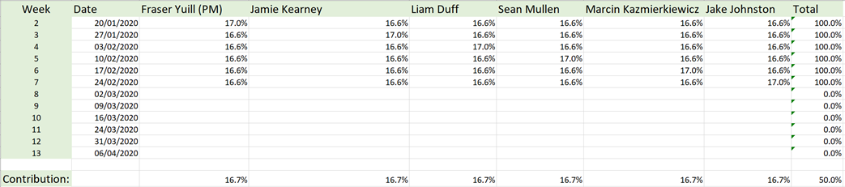

*Fig. 1 – Team Contribution Sheet, taken from excel document*